DO NOT YUGOSLAVIA! A visceral response in the era of artificial inteligence

Nora Lefa, Ema Alihodžić Jašarović, Sara Stojkanović

NORA LEFA, ΜΑ, MSc, PhD
Associate Professor,
School of Fine Arts, University of Ioannina
Contact: +306975027260, e-mail: nora_arch@yahoo.gr

EMA ALIHODŽIĆ JAŠAROVIĆ, PhD
Assistant Professor,
Faculty of Architecture, University of Montenegro
Contact: +38267437006, e-mail: emajasarovic@gmail.com

MSC SARA STOJKANOVIĆ, Montenegro
Contact: +38268677477, e-mail: sara@stojkanovic.com

Abstract
Since AI is increasingly complementing, and moreover, substituting for human intelligence in every aspect of our lives, it is bound to do so in the management of land. However positive a well-informed approach to administrating human beings’ most precious of natural resources can be, the drawbacks cannot be ignored: acting solely on typified logic, unhinged from human sympathy and emotions, can lead to monstrous results. Algorithms and learning processes alone, providing for the input on which AI operates, can lead to humans being turned to appurtenances of the land they rely on, the natural intelligence being unable to articulate substantial arguments against. We must trust visceral intelligence in counteracting rationality detached from humanity in order to harness the advantages the reliance on a multifaceted intelligence can offer.
These ideas are put to the test in an exhibition entitled Do Not Touch Yugoslavia!, A Visceral Response in the Era of Artificial Inteligence, following the Montenegrin call for participation in the competition for the selection of the national representative at the 2025 Venice Biennale of Architecture. Unmeditated, direct emotional reactions to the stimuli provided by encounter with Montenegrin land and soil, is the Janus’ face of paradise and hell. The epistemology of the encounter could be illustrated through ten days of paradise in Montenegro, symbolically depicted through memories of the Yugoslav train. Such accumulated memories, created by bodily experience in contact with the earth (body memory), will build an anthropological experience in space, and such a connection with a place (insidness) is irreplaceable. Equally important is the psycho-geography that we associate with artificial post-Yugoslav landscapes (,,toxic beauty’’), the construction of which encodes the memories and feelings of an unknown worker, who disappeared in the anonymity of Yugoslav ideology.

Viscelar intelligence, Yugoslavia, body memory, post Yugoslav landscapes, insidness

- ,,Ten days in paradise’’ - An Anthropological Experience of Space / Body Memory

The 2025 Venice Biennale of Architecture was themed Intelligens, Natural, Artificial, Collective. The organizer of the Montenegrin participation at the Biennale, the Ministry of Spatial Planning, Urbanism, and State Property of Montenegro, narrowed down the general framework to intelligence connected with earth and soil and called a competition for the selection of the national representative, addressing the issue of terram intelligere.
This sparked our interest in exploring how contemporary architecture could respond to the challenges posed by the lightning-fast advent of AI which tends to substitute for human intelligence in every aspect of our lives, and specifically in the management of land, given that recent advances have led to its widespread industrial adoption (T’kindt and Billaut 2006, Murdoch et al 2019, Shati et al 2025), with machine learning systems demonstrating “superhuman performance in a significant number of tasks” (Linardatos et al, 2020).
However positive a well-informed approach to administrating human beings’ most precious of natural resources can be, the drawbacks cannot be ignored. AI relies on data, that is, on the representation of reality in a series of unambiguous, explicit, bits of reality that can be homogenized and quantified so that they become comparable to other data. AI is based on machine learning, the automated detection of meaningful patterns in data. Machine learning aspires at “converting experience into expertise or knowledge” (Sahlev-Shwartz and Ben-David 2014, 19). The idea of quantifiable data representing experience is controversial. Acting solely on typified logic, unhinged from human sympathy and emotions, can lead to monstrous results as Max Horkheimer and Theodor Adorno have pointed out in their seminal Dialectic of Enlightenment (2002). Algorithms and learning processes alone, providing for the input on which AI operates, can lead, in our case, to humans being turned to appurtenance of the land they rely on, the natural intelligence being unable to articulate substantial arguments against.
It is therefore imperative that we balance artificial and natural intelligence with emotional intelligence, the kind of intelligence relying on sympathy. The visceral response to space is neither programmed nor rational, and it is impossible to simulate. It is tied to complex feelings and spontaneous emotions. This suggests that our bond with space is not merely cognitive, but deeply somatic - hence, profoundly unpredictable; and that is its most promising quality. As early as 1945, Maurice Merleau-Ponty (1962) demonstrated that the perception of space is not an abstract process, but one always mediated by the body and its senses. The anthropological experience of space thus points to the phenomenon of lived space (existential space), inseparably linked to the body as the instrument of perception. The body is not a mere biological object, but rather the subject of perception: space is experienced through the body. Consequently, architecture, does not exist solely as a manifestation of physically manipulated space, but rather as an event within the body, as articulated by thinkers and practitioners since at least the mid- twentieth century.
Maurice Merleau-Ponty introduced the notion of the habitual body, suggesting that the body “remembers.” Visceral intelligence, similarly, emphasizes the significance of embodied experience, what Juhani Pallasmaa, in The Eyes of the Skin: Architecture and the Senses, (2005) calls the “haptics of the body” and the visceral reactions space evokes (smells, sounds, textures, temperatures…). Gaston Bachelard, in his Poetics of Space (1969), wrote about how spaces can provoke intimate, unconscious, and visceral associations. Peter Zumthor explored in both his built oeuvre and his theory of architecture (2005) the atmospheric dimension of architecture, whose sensory impressions remain inscribed within visceral memory. Edward Relph (1976), conversely, critiques globalization and uniformity for producing placelessness. This approach stands as a critique of the increasingly dominant visual and sensationalist tendencies in architecture, further amplified by AI-driven effects.
Building upon these theoretical positions, we sought to demonstrate the importance of bodily memory and visceral intelligence by evoking collective memories of summer vacations on the Montenegrin coast during the former Yugoslavia. Simulating the socialist Yugoslav context, in which annual holidays were often defined by ten days at the seaside, this segment is symbolically titled “Ten Days in Paradise.”

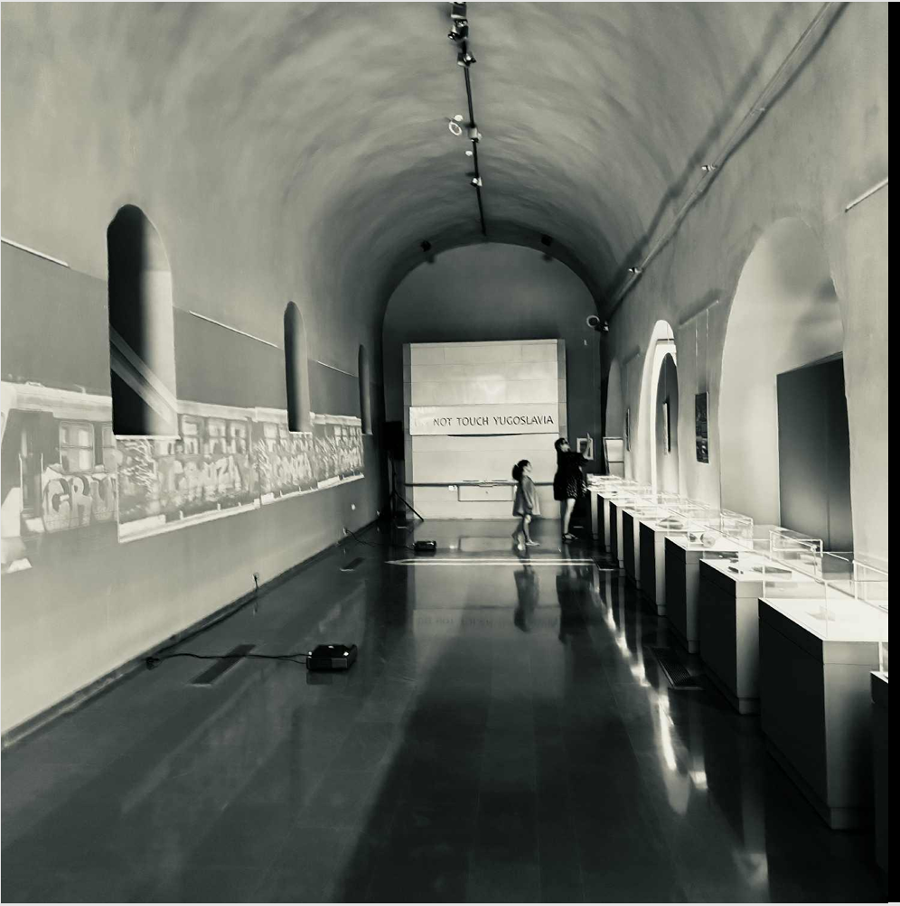
Image 1: The essence of the place is achieved by the juxtaposition of physical objects to projections of memory condensed in the moving image of a train -the means of transport to the “ten days in paradise”. “Do not touch Yugoslavia, A Visceral Response in the Era of Artificial Inteligence” exhibition, Sufari Sarai venue, Ioannina, Greece, July 13-20, 2025. Photo by Nora Lefa.

A large number of participants from across the former Yugoslavia recalled memories associated with people and places they vividly remembered: an evocative fusion of nostalgia, social dynamics, and cultural identity. Particularly compelling is the topography of memory tied to Yugoslav resorts, beaches, and campsites. This retrospective idealization of a certain time and space is deeply connected to a sense of safety and freedom. The summer holiday becomes a site where individual experiences merge into the collective. The collective rhythms of those times are primarily associated with encounters, not merely physical interactions, but moments of exchange that deepen visceral feelings. To connect these narratives, we employed a recurring motif: the Yugoslav train - a physical and symbolic link that endured even after the dissolution of Yugoslavia. The train, as a spatial and social experience, becomes a metaphorical vessel for collective meaning. Paul Connerton, in his notion of embodied memory (1989), explains how social memory is transmitted through ritualized bodily practices. Understanding space as both a social and symbolic category, our project demonstrates that neither physical borders nor decades of political fragmentation have erased the visceral and bodily memory of a shared space.
Such an approach offers a new method for understanding space: one that treats it as a site of memory, in which visceral intelligence plays a key role, counter to the predictive rationality of AI. This artistic experiment reveals that physical boundaries are rational constructs unrecognized by visceral sensation. Operating on a pre-reflective level, these sensations propose a new perception of space and its essential values. Spatial borders thus become permeable, open to empathy and remembrance, where bodily memory acts as connective tissue. This authentic, unsimulated experience of space generates sensations that remain as genuine signals within the body. They can profoundly alter our perception of space, making visceral experience both the true measure of space and a methodological tool that honors the body as an archive of spatial experience.
In contrast, AI-generated spaces, devoid of knowledge about authentic bodily reactions, are mere simulations. Algorithms cannot replicate or simulate the unrepeatable, subjective, and intuitive insights of the body. In this sense, the body becomes the antithesis to algorithmic rationalism.
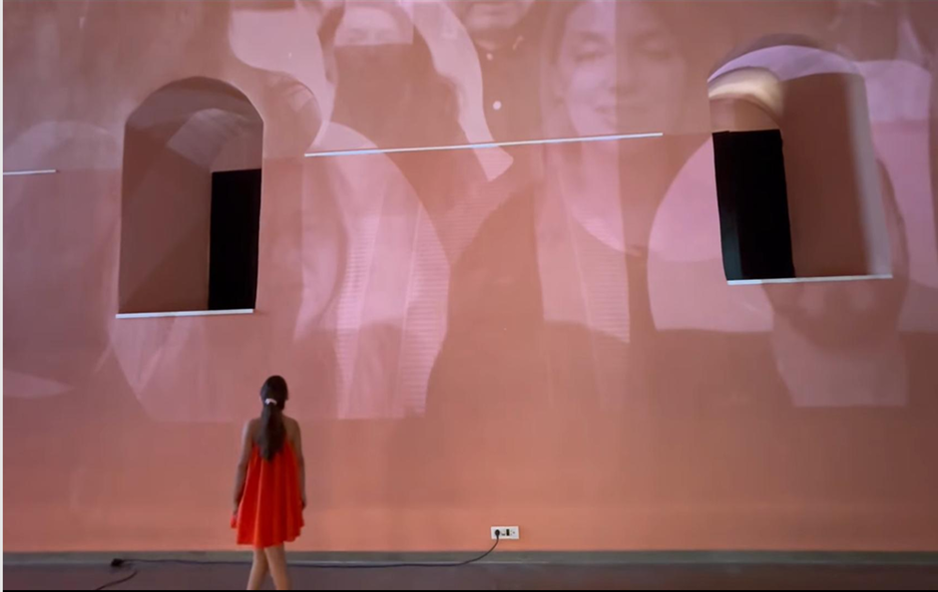
Image 2: People speaking all the languages spoken in Yugoslavia testify of their experience of the 10 days in paradise. “Do not touch Yugoslavia, A Visceral Response in the Era of Artificial Inteligence” exhibition, Sufari Sarai venue, Ioannina, Greece, July 13-20, 2025. Photo by Nora Lefa

- Beauty toxic - The Post-Yugoslav Landscape

Drawing upon the principles of psychogeography, the interpretation of spaces that convey complex emotions, trauma, and collective history, we aimed to affirm the continuing value of the Yugoslav space, even in its post-political form, as a shared cultural territory. Just as the memory of ten days of seaside vacation embodied a powerful sense of collective belonging, the memory of labor within Yugoslav industrial complexes reflects the collective spirit and working-class identity of that era. This segment of the project seeks to emphasize the significance of spatial residues: the Yugoslav topographies born of a grand ideology of progress.
The artificiality of Yugoslavia’s modernist vision manifested in monumental industrial constructions that dramatically reshaped both landscape and society. These projects were not merely economic artifacts but spatial inscriptions of an ideology that transformed topography and people. Today, many of these sites stand abandoned and degraded, lingering as unresolved spatial problems of the country, with no solution even today. Such post-Yugoslav landscapes encode the memories and emotions of the anonymous worker, a figure who vanished into the anonymity of the Yugoslav ideological project, yet whose presence remains deeply inscribed within space. These traces may prove invaluable, not only in reconstructing collective memory, but also in rethinking these sites as places of renewed encounter.
Today, post-Yugoslav landscapes stand as visual, spatial, ecological, and social scars that call for critical re-examination. Paradoxically, many appear visually striking, even aesthetically seductive, despite the fact that, in essence, they are environmental black spots. Hence the title “Beauty Toxic” - a term denoting a dual, fundamentally opposed spatial condition.
One of the most powerful collective memories of that era is the story of the construction of the Mratinje Dam, during which hundreds of residents and families were displaced when the town of Plužine was submerged under water for the creation of the hydroelectric power plant. The memory of the place now submerged endures as a bearer of the social narrative of labor identity, modernization, and collective progress. As Pierre Nora might suggest, these topographies function as lieux de mémoire, “memory machines.” In this case, however, water becomes the medium of memory, a surface that conceals traces of the past and deeply rooted recollections. Their significance lies not only in materiality, but also in the emotional and symbolic imprints that have shaped the identity of the community. This powerful remembrance, poised between pride and loss, constitutes what might be termed conflictual memory.

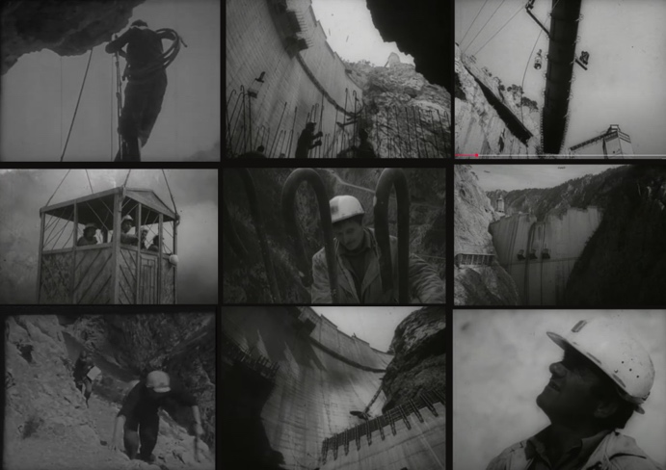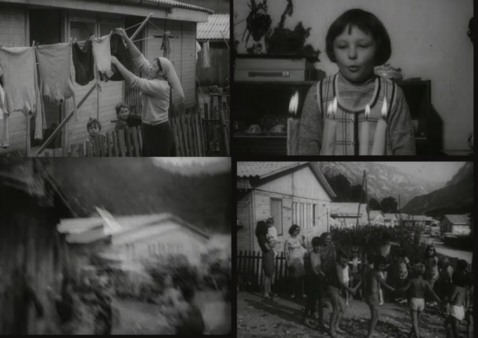
Image 3: Stills from the documentary Izgradnja EXE PIva Изградња ХЕ Пива https://www.youtube.com/ watch?v=hHBATOhpFpE

In this edition dedicated to the residues of Yugoslav technological optimism, we also presented the story of the Aluminium Plant (KAP), one of the most emblematic sites of collective workers’ memory. Today, KAP stands as a frozen image of power, a topos that once symbolized industrial strength and now represents one of the city’s leading ecological problems. The “Red Lake”, a vast expanse of toxic sludge, appears visually exotic, almost painterly in its intensity. Socialist solidarity and technological optimism have been reduced to the ruins of a collective utopia, one that may yet be open to new interpretations. Can visceral intelligence and collective memory establish new value for such places, much like Alberto Burri’s Cretto di Burri (1984–1989), the monumental installation created on the ruins of Gibellina, the Sicilian town destroyed by the 1968 earthquake. Burri “poured” white concrete over the devastated landscape, tracing the pattern of the original streets as wide fissures resembling cracked earth. As visitors walk through these crevices, they activate memories-historical as well as bodily, transforming the site into an experiential entity rather than a merely visual symbol.

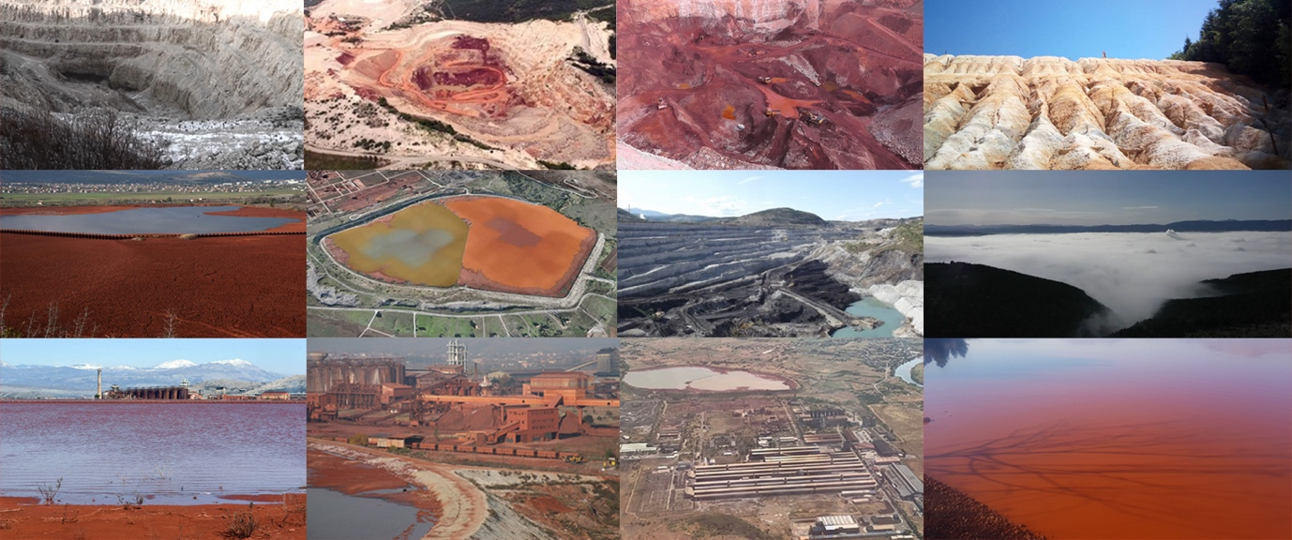
Image 4. Abandoned landscapes in the body of Montenegro. 2010’s-2020’s. Photographs from the public domain -names of authors not mentioned.

We also depicted the tragic fate of the Ulcinj Saltworks and its surreal landscape, now threatened by total destruction and conversion into construction land. Once a powerful industrial complex and a key producer of salt, the Saltworks can now be understood as a site of bodily and collective memory, embodied in the smells, the tactile grain of salt, the sound of the wind, and the physical labor of extraction. The ritualized, haptic process of salt harvesting endures within visceral memory, serving as an archive of bodily and collective experience.

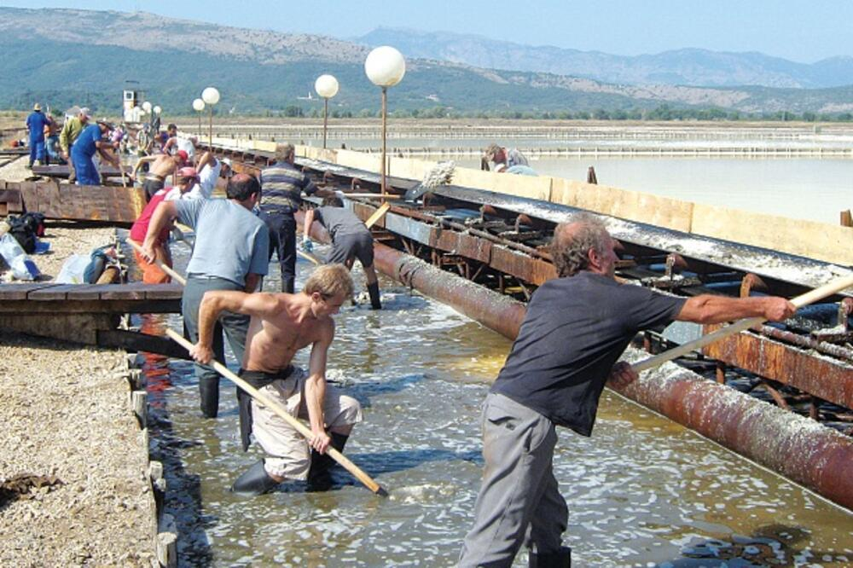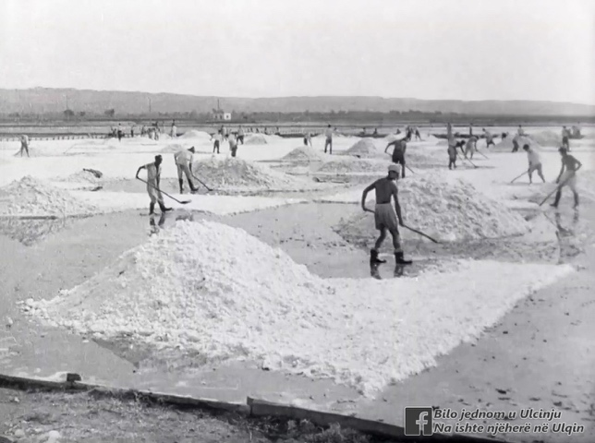
Image 5. Saltworks in Montenegro. 1970’s. Photographs from the public domain -names of authors not mentioned.

Equally striking are the beauty-toxic landscapes of coal and bauxite mines. Their topographies bear the imprinted traces of all those who once worked there. The visceral experience of these laborers, marked by fatigue and pain, testifies to an ideology that ended without fulfillment. Feelings of safety and danger remain encoded in the body even after the mines have become nothing more than black toxic terrains. Fragments of these sites are symbolically displayed in the exhibition - sealed within glass boxes, visible yet untouchable. These contained objects include 3D-printed terrains and original material elements of the soil: salt, red sludge from KAP, coal, bauxite, stone, concrete. The exhibition’s thematic duality directly reflects the double meaning embedded in both the title and the conceptual realization of the project Do not touch Yugoslavia! A Visceral Response in the Era of Artificial Inteligence.

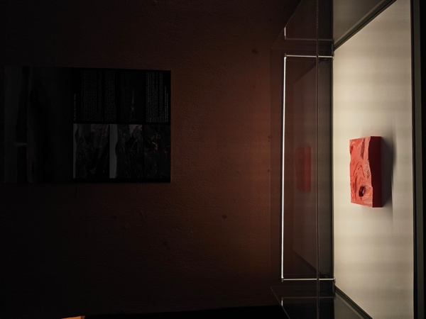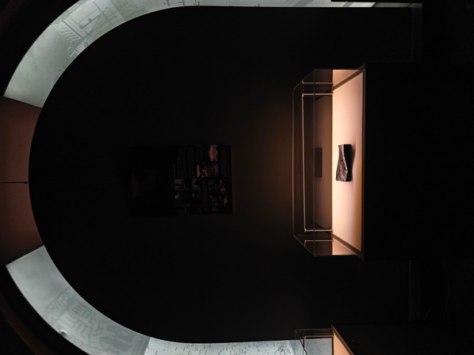
Image 6. Charcoal and 3D prints of selected natural formations displayed at the “Do not touch Yugoslavia, A Visceral Response in the Era of Artificial Inteligence” exhibition, Sufari Sarai venue, Ioannina, Greece, July 13-20, 2025. Photos by Nora Lefa

- DO NOT TOUCH YUGOSLAVIA!

At first glance, the phrase Do Not Touch Yugoslavia! Do not touch Yugoslavia! A Visceral Response in the Era of Artificial Inteligence appears paradoxical. On one level, it warns of the danger inherent in post-Yugoslav toxic sites that demand critical re-examination; on another, it alludes to the nostalgic imaginary of Yugoslavia: something that, perhaps, should not have been touched at all. The message exists between the physical and the symbolic, metaphorically cautioning against disturbing histories whose disruption might endanger both memory and a sense of security. The work intentionally provokes tension, compelling reflection on the conflict between the real and the imagined past, between historical reality and idealized heritage.
At the same time, it implies resistance and serves as a critique of historical revisionism, often manifested in the negative discourse of post-Yugoslav societies. The toxic beauty topographies of former Yugoslavia become bodies of space, preserving the experiences and emotions of the generations that built them. Toxicity itself becomes both a symbol and a metaphor - for the political, economic, and social “toxins” inherited from the Yugoslav past.
At its core, the message carries an interactive concept, an invitation to collective remembrance as part of a shared identity. It is not merely a nostalgic warning, but rather a philosophical and architectural framework that emphasizes the importance of visceral intelligence and bodily memory. Regardless of whether the experience was positive or painful, the message points to the inviolability of collective experience - that which cannot, and should not, be “touched.” Neglecting such feelings threatens to erode the layered strata of memory that could instead serve as the foundation for new modes of spatial understanding and valuation. Do Not Touch Yugoslavia! thus becomes an ethical and epistemological principle: one that acknowledges bodily and collective memory as authentic forces capable of articulating new possibilities for post-Yugoslav topographies.
This method challenges the dominance of abstract rationality and algorithmic planning characteristic of AI paradigms, treating every space as a mnemonic entity. Respecting visceral sensations creates a collective archive, opening the way toward a new ethics of architectural and spatial engagement.
Finally, the Yugoslav train reappears as a symbolic reminder of the once-shared Yugoslav space - a guide through time that archives memories across a common geography. These memories, fragile yet enduring, must neither be neglected nor touched.

Conclusion

The faster technology runs, the harder it is for the human brain to keep pace with it. We should therefore wrestle back the tools that control the creative process. If we surrender our creativity to AI and let it take our place in developing and finishing our work, we will cease thinking, and cease improving ourselves; we will not even be able to create algorithms controlling AI. At this end we should mobilize the very essence of ourselves that cannot be matched by AI. This is what we attempted to do with Do not touch Yugoslavia! A Visceral Response in the Era of Artificial Inteligence exhibition. We drew upon the principles of psychogeography, the interpretation of spaces that convey complex emotions, trauma, and collective history, aiming at affirming the continuing value of the Yugoslav space, even in its post-political form, as a shared cultural territory that ChatGPT cannot feel. The accumulated memories, created by bodily experience in contact with earth (body memory), builds an anthropological experience in space. Such a connection is irreplaceable -especially the psycho-geography that we associate with artificial post-Yugoslav landscapes (,,toxic beauty’’), the experinece of the place and the collective memory condenced in the ,Ten days in paradise’,promised to all citizens of the socialist stae. We depicted the tragic fate of the Ulcinj Saltworks and its surreal landscape, now threatened by total destruction and conversion into construction land, whereby the smell and taste of soil, of minerals, of the sea and salt are eliminated. In this case, however, water becomes the medium of memory, a surface that conceals traces of the past and deeply rooted recollections. The matter was not to convey some pieces of information about its fate, but to recreate the experience of this place, based on the materiality, and ultimately facilitate the emotional perception that only human mind can achieve.
And in the end the phrase Do Not Touch Yugoslavia, this toxic beauty which is metaphoric and so complex that is absolutely dangerous for an algorithm to touch and to give a definition. Algorithms and learning processes alone, providing for the input on which AI operates, can lead to humans being turned to appurtenances of the land they rely on, the natural intelligence being unable to articulate substantial arguments against. But on the other hand, we cannot ignore the benefits provided by AI, when used in the right way. Saving time by collecting information and putting it in order, reminding us of the literature that slipped our mind; but not substituting for us in the creative process. So the answer will be that the It is imperative that we balance artificial and natural intelligence with emotional intelligence, with our intuition, with visceral intelligence.

A Visceral Response in the Era of Artificial Inteligence

References

-Bachelard, Gaston. 1969. The poetics of space. Boston: Beacon Press.

-Connerton, Paul. 1989. How societies remember. Cambrige University Press.

-Horkheimer, Max and Theodor Adorno. 2002. Dialectic of Enlightenment. Stanford university Press.

-Linardatos, P; V. Papastefanopoulos; and S. Kotsiantis. 2020. “Explainable ai: A review of machine learning interpretability methods.”Entropy,23, 1, 18.

-Merleau Ponty, M. Phenomenology of Perception. 1962. New York: Humanities Press, and London: Routledge & Kegan Paul.

-Murdoch, W.J; C. Singh; K. Kumbier; R. Abbasi-Asl; and B. Yu. 2019. “Definitions, methods, and applications in interpretable machine learning.”Proceedings of the National Academy of Sciences, 116, 44, 22071–22080.

-Pallasmaa, J. The eyes of skin. 2005. Chichester, West Sussex: John Wiley and Sons.

-Relph, Edward. 1976. Place and Placelessness. London: Pion.

-Shati, Pouya; Yuliang Song; Eldan Cohen; Sheila A. McIlraith (2025). Optimal Decision Trees for Interpretable and Constrained Clustering. In Journal of Artificial Intelligence Research, Vol. 84. DOI: https://doi.org/10.1613/jair.1.18144.

-Shalev-Shwartz S. and S. Ben-David. 2014.Understanding machine learning: From theory to algorithms. Cambridge university press
.
-T’kindt V. and J.-C. Billaut. 2006. Multicriteria scheduling: theory, models and algorithms. Springer Science & Business Media

- Zumthor, Peter. 2005. Atmospheres. Basel: Birkhauser.

NORA LEFA, ΜΑ, MSc, PhD
Associate Professor,
School of Fine Arts, University of Ioannina
Contact: +306975027260, e-mail:nora_arch@yahoo.gr

Nora Lefa is an architect and visual artist. She is Associate Professor of Multimedia and Video-Art at the School of Fine Arts, University of Ioannina, Greece. She has presented her work in several solo and group exhibitions in Athens, Sarajevo, Belgrade, Skopje, New York, Miami, Barcelona, Zurich, Paris, London and Venice. Her latest solo exhibition was held at Casale dei Cedrati, Villa Doria Phamphilj, Rome, Sept. 01-10, 2024. She has won distinctions for her architectural and artistic work. She has resented papers in several international conferences and has authored two books: Sarajevo Again (Athens: Plethron 2020, in Greek; Sarajevo: International Peace center 2023 in English and in Bosnian), and Buildings Used (London: Routledge 2019 -co-authored). She has co-organised international conferences and exhibitions, and was a member of the respective scientific committees and jury. She has translated into Greek Serbian and Bosnian poetry.

EMA ALIHODŽIĆ JAŠAROVIĆ, PhD
Assistant Professor,
Faculty of Architecture, University of Montenegro

Architect and educator. She deals with research related to the theoretical aspects of the socio-spatial identity of the city, and her special interest belongs to the questioning of the role of collective memory, within which she has published many papers in international scientific journals and conferences. She is the winner of several awards at international architectural exhibitions, and at architectural and urban planning competitions. She was nominated for the Piranesi award (2022). Twice it was part of the Montenegrin installation at the Architecture Biennale in Venice (2010 and 2023). She is part of the editorial team for the documentary Decoding Montenegro, and a member of the selection team at the Balkan Architecture Biennale (2025).
In the role of mentor, she led several notable international student workshops, EASA Montenegro 2021, Pimp my roof (2015), Ludis in sale (Nant, 2024), Mock Up Junk Lab (2025). She was the vice president of the Association of Architects of Montenegro. She is part of the creative team that started the non-institutional cultural center Kolektor in the former Titex factory.

MSC SARA STOJKANOVIĆ, MONTENEGRO
Architect and engineer working across Europe, Asia, and Africa. Her fieldwork and project-based practice focus on regenerative systems, humanitarian architecture, and participatory design.
She is the recipient of multiple international awards and the first fellow of the architectural academy mentored by Pritzker Laureates, through which she continues professional collaboration with the studio Snøhetta.
In 2023, she founded the Change Agency Umoja Maono Humanitarian Organization in East Africa, concentrating on sustainable interventions that enhance the societal and ecological resilience of local communities. She led the realization of the first Community-led Regeneration Center in Tanzania (Maasai tribe, Kilimanjaro, 2024), integrating local resources and practices through participatory design processes.
Since 2018, she has been a national coordinator for EASA, affiliated with the RIBA.
She is a producer and director of documentary-humanitarian films that explore the relationship between space and communities in Montenegro and abroad.

